Assessment: Lab Exam 02

Student Name: Adam Di Cioccio

Lab Professor Name: Mohammad Patoary

Lab Section Number: 321

Due Date: December 8, 2020

# Pseudocode

**AdamDiCioccioLabExam02_321.java**

Import scanner

Boolean programIsRunning

New class Egg

New class Menu

Create scanner

While loop

Call method from Menu.java to display options

Ask user for input

Set user input into variable

If statement (input ==321)

Ask user for input for ounces

Set input into variable

Call setter from egg.java

Ask user for input for price per ounce

Set input into variable

Call setter from egg.java

Else if (input ==642)

Call calculateSalesCost from egg.java

Display the calculations

Else if (input ==963)

Display exit message

Close scanner

Set Boolean to false stopping while loop

Else

Display that this option is invalid and restart while loop

# Screenshot of program running

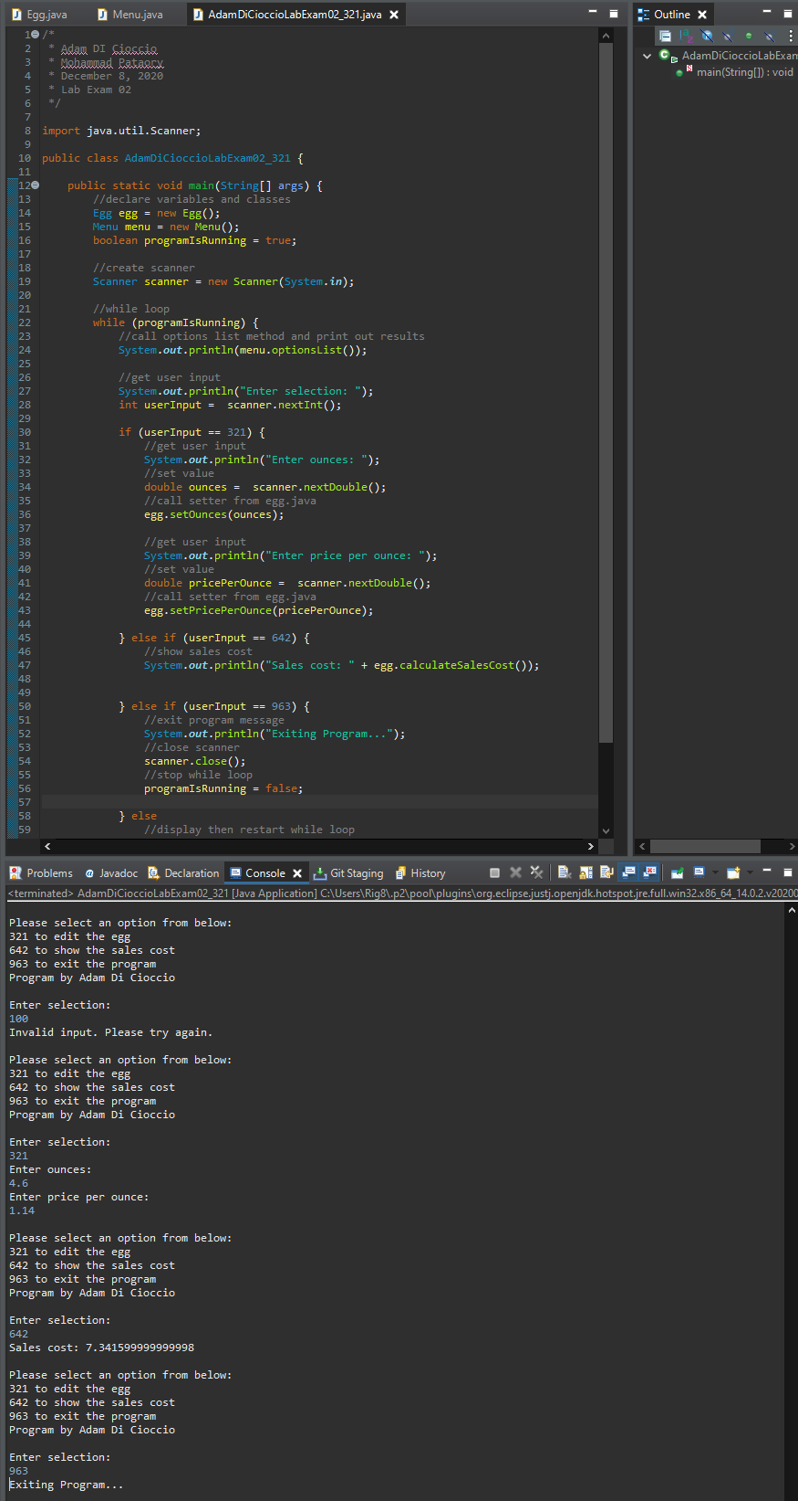

# References / Sources Cited